| **TEST REPORT** | | | | | | | | |
| --- | --- | --- | --- | --- | --- | --- | --- | --- |
| **PROJECT NAME :TRELLO** | | | | | | | | |
| **EXECUTED** |  | **PASS 181** | | | | | | |
| **FAIL 0** | | | | | | |
| **(Total) TEST EXECUTED** | | | | | | |
| **(PASS+FAIL) 181** | | | | | | |
| **Functions** | **Sub-Functions** | **Description** | **No of test cases written** | **No of test cases executed** | **%TCs Pass** | **%TCs Fail** | **Priority** | **Remark** |
| Add to card |  | verify whether we can able to perform add  A card to the list operation | 18 | 18 | 100% | 0% | High |  |
| Add to card | Dates | Verify the Dates functionality |  |  |  |  | High |  |
|  |  | Verify the a particular Dates functionality |  |  |  |  | High |  |
|  |  | Verify the Start Date checkbox functionality |  |  |  |  | High |  |
|  |  | Verify the due Date check box functionality |  |  |  |  | High |  |
|  |  | Verify the due Date check box is clickable or not functionality |  |  |  |  | High |  |
|  |  | Verify whether user is able to edit dates manually |  |  |  |  | High |  |
|  |  | Verify whether selected date is displayed on due date box |  |  |  |  | High |  |
|  |  | Verify whether next month calendar is displayed |  |  |  |  | High |  |
|  |  | Verify whether previous month calendar is displayed |  |  |  |  | High |  |
|  |  | Verify whether default reminder is displayed |  |  |  |  | High |  |
|  |  | Verify whether selected option is displayed on set due date reminder |  |  |  |  | High |  |
|  |  | Verify whether user is able to select multiple option at a time |  |  |  |  | High |  |
|  |  | Verify whether dates reminder list is displayed |  |  |  |  | High |  |
|  |  | Verify whether the calendar is displayed to edit to the user |  |  |  |  | High |  |
|  |  | Verify the previous date is displayed in calendar |  |  |  |  | High |  |
|  |  | Verify whether the selected date is removed from the particular list |  |  |  |  | High |  |
|  |  | Verify whether the date page is closed |  |  |  |  | High |  |
|  | Attachment | Verify the Attachment functionality | 19 | 19 | 100% | 0% | High |  |
|  |  | Verify whether it is opening the computer drive folder |  |  |  |  | High |  |
|  |  | Verify whether the selected file is attached in the list |  |  |  |  | High |  |
|  |  | Verify whether it is displaying the cards and boards list to attach in the list |  |  |  |  | High |  |
|  |  | Verify whether the card or board is attached to a particular list and displayed |  |  |  |  | High |  |

|  |  | Verify whether valid board or card list is displayed in the list |  |  |  |  | High |  |
| --- | --- | --- | --- | --- | --- | --- | --- | --- |
|  |  | Verify whether it is redirecting to attach form page |  |  |  |  | High |  |
|  |  | Verify whether Attachment page is closed |  |  |  |  | High |  |
|  |  | Verify whether it displays choose an account page to go to google drive |  |  |  |  | High |  |
|  |  | Verify whether the file is attached and displayed in the list |  |  |  |  | High |  |
|  |  | Verify whether dropbox sign in page is displayed |  |  |  |  | High |  |
|  |  | Verify whether box sign in page is displayed |  |  |  |  | High |  |
|  |  | Verify whether a error message is displayed”File exceeds the 250MB limit’ |  |  |  |  | High |  |
|  |  | Verify whether it is displaying the microsoft login page |  |  |  |  | High |  |
|  |  | Verify whether attach a link is highlighted and a blinking bar is displayed |  |  |  |  | High |  |
|  |  | Verify whether attach button is enabled and link name box is displaying |  |  |  |  | High |  |
|  |  | Verify whether attach link is displayed |  |  |  |  | High |  |
|  |  | Verify whether it is redirected to power-ups for trello page |  |  |  |  | High |  |
|  |  | Verify whether attach from page is closed |  |  |  |  | High |  |
|  | Checklist | Verify whether a box is highlighted and a blinking bar is displaying | 23 | 23 | 100% | 0% | Major |  |
|  |  | Verify whether previous used title name is displayed |  |  |  |  | Major |  |
|  |  | Verify whether a name is displayed as add an item |  |  |  |  | Major |  |
|  |  | Verify whether given title name is displayed on title and copy item from box |  |  |  |  | Major |  |
|  |  | Verify whether duplicate selected title name is displayed |  |  |  |  | Major |  |
|  |  | Verify whether the name is changed on title bar |  |  |  |  | Major |  |
|  |  | Verify whether provide title name is displayed |  |  |  |  | Major |  |
|  |  | Verify whether add checklist page is closed |  |  |  |  | Major |  |
|  |  | Verify whether add an item box is displayed |  |  |  |  | Major |  |
|  |  | Verify whether user is able to give any character value in the box |  |  |  |  | Major |  |
|  |  | Verify whether item name is added under checklist |  |  |  |  | Major |  |
|  |  | Verify whether user is able to assign a checklist to particular member |  |  |  |  | Major |  |
|  |  | Verify whether user is able to set due date |  |  |  |  | Major |  |
|  |  | Verify whether user can mention members in the checklist |  |  |  |  | Major |  |
|  |  | Verify whether user can attach emoji in the add an item box |  |  |  |  | Major |  |
|  |  | Verify whether add an item box is closed |  |  |  |  | Major |  |
|  |  | Verify whether edit box is opened |  |  |  |  | Major |  |
|  |  | Verify whether changed title name is displayed |  |  |  |  | Major |  |
|  |  | Verify whether a warning message is displayed |  |  |  |  | Major |  |
|  |  | Verify whether the checklist is deleted permanently |  |  |  |  | Major |  |
|  |  | Verify whether the percentage bar and hide checked items is displayed |  |  |  |  | Major |  |
|  |  | Verify whether item is hidden from the list |  |  |  |  | Major |  |
|  |  | Verify whether the checklist is closed |  |  |  |  | Major |  |
|  | Cover | Verify the Cover functionality | 15 | 15 | 100% | 0% | Major |  |
|  |  | Verify whether background is changed as per the selected color and size should is enabled |  |  |  |  | Major |  |
|  |  | Verify whether it is not selecting multiple color |  |  |  |  | Major |  |
|  |  | Verify whether cover page is formatted as per the selected size |  |  |  |  | Major |  |
|  |  | Verify whether cover page is removed from the list |  |  |  |  | Major |  |
|  |  | Verify whether computer drive is opened |  |  |  |  | Major |  |
|  |  | Verify whether attached file is displayed on attachment and cover is displayed on the right side of the card |  |  |  |  | Major |  |
|  |  | Verify whether the name of the particular unsplash is displayed |  |  |  |  | Major |  |
|  |  | Verify whether the link of the particular image is displayed |  |  |  |  | Major |  |
|  |  | Verify whether it is redirected to the unsplash website |  |  |  |  | Major |  |
|  |  | Verify whether page search page is opened |  |  |  |  | Major |  |
|  |  | Verify whether photos related to input data is displayed |  |  |  |  | Major |  |
|  |  | Verify whether when clicking on photos from unsplash it is redirected to unsplash website |  |  |  |  | Major |  |
|  |  | Verify whether it is coming to the cover page |  |  |  |  | Major |  |
|  |  | Verify whether when clicked on close icon the cover page is closed |  |  |  |  | Major |  |
| Label | Search label | Verify the search Label | 17 | 17 | 100% | 0% | High |  |
|  |  | Verify Functionality of search label |  |  |  |  | High |  |
|  |  | Verify Functionality of search label |  |  |  |  | High |  |
|  | Create new label | Verify functionality of create new label |  |  |  |  | High |  |
|  | Name | Verify functionality of Name |  |  |  |  | High |  |
|  | Select color | Verify functionality of select color |  |  |  |  | High |  |
|  | Create button | Verify functionality of create button |  |  |  |  | High |  |
|  | Edit button | Verify functionality of Edit button |  |  |  |  | High |  |
|  | Name | Verify functionality of Name |  |  |  |  | High |  |
|  |  | Verify functionality of Name |  |  |  |  | High |  |
|  | Select color | Verify functionality of select color |  |  |  |  | High |  |
|  |  | Verify functionality of select color |  |  |  |  | High |  |
|  | Save | Verify functionality of save |  |  |  |  | High |  |
|  | Delete button | Verify functionality of Delete Button |  |  |  |  | High |  |
|  |  | Verify functionality of Delete Button |  |  |  |  | High |  |
|  | Button | Verify functionalityEnable color  blind friendly mode |  |  |  |  | High |  |
|  |  | Verify functionality disable color  blind friendly mode |  |  |  |  | High |  |
| Add | Text | Verify functionality of Text | 4 | 4 | 100% | 0% | High |  |
|  | Add | Verify functionality of add |  |  |  |  | High |  |
|  | Edit button | Verify functionality of edit |  |  |  |  | High |  |
|  | Save | Verify functionality of save |  |  |  |  | High |  |
| Board setting |  | Verify whether the board setting is available for  Particular board | 42 | 42 | 100% | 0% | High |  |
|  |  | Verify the board setting option is clickable or not |  |  |  |  | High |  |
|  |  | Check the back button |  |  |  |  | High |  |
|  | XYZ Board name | verify whether the board name is clickable |  |  |  |  | High |  |
|  |  | Verify whether user is able to edit the board name |  |  |  |  | High |  |
|  |  | Verify the cancel button is working in the XYZ board name edit pop-up |  |  |  |  | High |  |
|  | XYZ workspace name | Verify whether workspace name is clickable |  |  |  |  | High |  |
|  |  | Verify whether user is able to change the workspace |  |  |  |  | High |  |
|  |  | Verify the user is able to save the changed workspace details |  |  |  |  | High |  |
|  |  | Verify the close icon functionality on the change workspace page |  |  |  |  | High |  |
|  | Edit labels | Verify the edit labels option is clickable or not |  |  |  |  | High |  |
|  |  | Verify user is able to edit the labels |  |  |  |  | High |  |
|  |  | Verify user is able to create new labels |  |  |  |  | High |  |
|  |  | Verify the functionality of the done button in the edit label page |  |  |  |  | High |  |
|  |  | Verify the functionality of CANCEL button in the New label page |  |  |  |  | Major |  |
|  | Background | Verify the Background button should clickable |  |  |  |  | Major |  |
|  |  | Verify the Background color functionality |  |  |  |  | Major |  |
|  |  | Verify the Back arrow button functionality |  |  |  |  | Major |  |
|  |  | Verify the Background Photos functionality |  |  |  |  | Major |  |
|  |  | Verify the search button on photos page |  |  |  |  | Major |  |
|  |  | Verify the Back arrow button functionality on photos page |  |  |  |  | Major |  |
|  |  | Verify the +icon functionality on board background page |  |  |  |  | Major |  |
|  |  | Verify the take photo option on upload background pop-up |  |  |  |  | Major |  |
|  |  | verify the close icon functionality on the take photo option |  |  |  |  | Major |  |
|  |  | Verify make background tiled/scaled option on custom background |  |  |  |  | Major |  |
|  |  | Verify the delete background option on custom background |  |  |  |  | Major |  |
|  |  | Verify the file option functionality on Upload background pop-up |  |  |  |  | Major |  |
|  | leave board | Check whether leave board option is enabled |  |  |  |  | High |  |
|  |  | Verify the leave board functionality |  |  |  |  | High |  |
|  |  | Verify the rejoin option functionality |  |  |  |  | High |  |
|  | Visibility | Verify whether the visibility option is enabled |  |  |  |  | High |  |
|  |  | Verify the radio button functionality |  |  |  |  | High |  |
|  |  | Verify the cancel button functionality on the visibility pop-up page |  |  |  |  | High |  |
|  | Commenting | Check whether commenting option is enabled |  |  |  |  | High |  |
|  |  | Verify the radio button functionality on commenting page |  |  |  |  | High |  |
|  |  | Verify the cancel button functionality on the commenting pop-up page |  |  |  |  | High |  |
|  | Let members add others option | Verify whether the user is able to enable and disable the check box |  |  |  |  | High |  |
|  | self join | Verify whether the user is able to enable and disable the check box |  |  |  |  | High |  |
|  | Enable card cover images | Verify whether the user is able to enable and disable the check box |  |  |  |  | High |  |
|  | Available offline | Verify whether the user is able to enable and disable the check box |  |  |  |  | High |  |
|  | Close board | Verify the close board option functionality |  |  |  |  | High |  |
|  | back arrow button | Verify the Back arrow button functionality |  |  |  |  | High |  |
| Add to cart | Member | Verify whether to create a member in a functionality | 8 | 8 | 100% | 0% | High |  |
|  |  | Verify whether to create a member in a functionality with invalid member |  |  |  |  | High |  |
|  |  | Verify whether to create a Empty Member |  |  |  |  | High |  |
|  |  | Verify whether to add a member. |  |  |  |  | High |  |
|  |  | Verify whether to delete a member. |  |  |  |  | High |  |
|  |  | Verify whether to add 2 members at a time. |  |  |  |  | High |  |
|  |  | Verify whether to search a member |  |  |  |  | High |  |
|  |  | Verify to search a member is not in Board members |  |  |  |  | High |  |
| Card | Adding Card | Verify whether the add card button is clickable or not | 10 | 10 | 100% | 0% | High |  |
|  |  | Verify whether there is add card option is there or not in options |  |  |  |  | High |  |
|  |  | verify whether when we click on add card text box is opening or not |  |  |  |  | High |  |
|  |  | verify whether in text box we are able to give card name or not |  |  |  |  | High |  |
|  |  | verify whether we can remove the card name in text box or not |  |  |  |  | High |  |
|  |  | verify whether add card button is present or not |  |  |  |  | High |  |
|  |  | Verify whether the add card button is clickable or not |  |  |  |  | High |  |
|  |  | verify whether we can edit the existing card name or not |  |  |  |  | High |  |
|  |  | Verify whether we can add multiple cards with same card name |  |  |  |  | High |  |
|  |  | verify whether edit option is there or not |  |  |  |  | High |  |
| Copy list | Copy list | Verify whether the copy list option is present or not | 7 | 7 | 100% | 0% | High |  |
|  |  | Verify inside copy list option is clickable or not |  |  |  |  | High |  |
|  |  | Verify whether the same name of list what we copied is displaying or not |  |  |  |  | High |  |
|  |  | Verify whether the copied list is appeared in main board or not |  |  |  |  | High |  |
|  |  | Verify whether create list option is clickable or not |  |  |  |  | High |  |
|  |  | Verify whether create list option is there or not |  |  |  |  | High |  |
|  |  | Verify whether the backward button is there or not |  |  |  |  | High |  |
| Move list | Moving list | Verify whether the close button is there or not | 13 | 13 | 100% | 0% | High |  |
|  |  | Verify inside move list option is clickable or not |  |  |  |  | High |  |
|  |  | verify whether board and position options are present or not |  |  |  |  | High |  |
|  |  | verify whether the board name displaying is current workspace board or not |  |  |  |  | High |  |
|  |  | verify whether we can change the board to another workspace or not |  |  |  |  | High |  |
|  |  | verify whether the position has different positions or not |  |  |  |  | High |  |
|  |  | verify whether the position count is equal to number of lists in board |  |  |  |  | High |  |
|  |  | Verify whether the backward button is there or not |  |  |  |  | High |  |
|  |  | Verify whether the close button is there or not |  |  |  |  | High |  |
|  |  | Verify whether the move button is there or not |  |  |  |  | High |  |
|  |  | verify whether after clicking the move button list is moving to that position or not |  |  |  |  | High |  |
|  |  | verify whether the moved list contains all the cards of original list or not |  |  |  |  | High |  |
|  |  | verify whether the list is moving to the different workspace that we selected |  |  |  |  | High |  |
| watch | watch option | Verify whether the watch list option is present in options or not | 5 | 5 | 100% | 0% | High |  |
|  |  | Verify inside watch list option is clickable or not |  |  |  |  | High |  |
|  |  | Verify whether after clicking on watch option some symbol is displaying on the left of options in list |  |  |  |  | High |  |
|  |  | verify whether the tick mark is present at the side of watch option after clicking watch option |  |  |  |  | High |  |
|  |  | Verify whether that symbol is displaying only for that particular list |  |  |  |  | High |  |

Screenshots of all the above mentioned Test Cases

**Board setting**

1.For board setting option when clicked on 3 dots

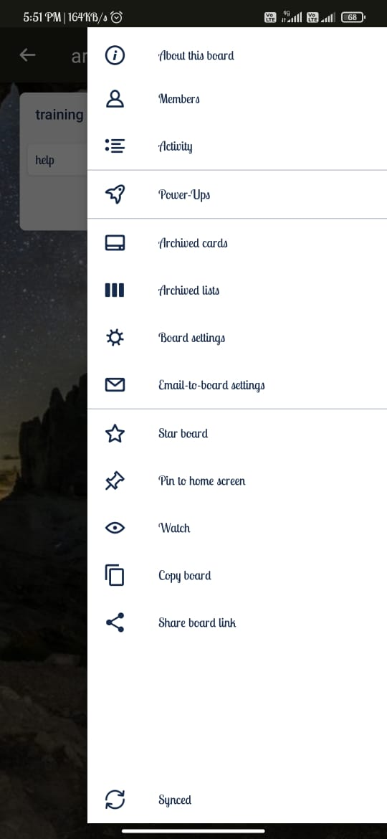

2.For Before updating board name

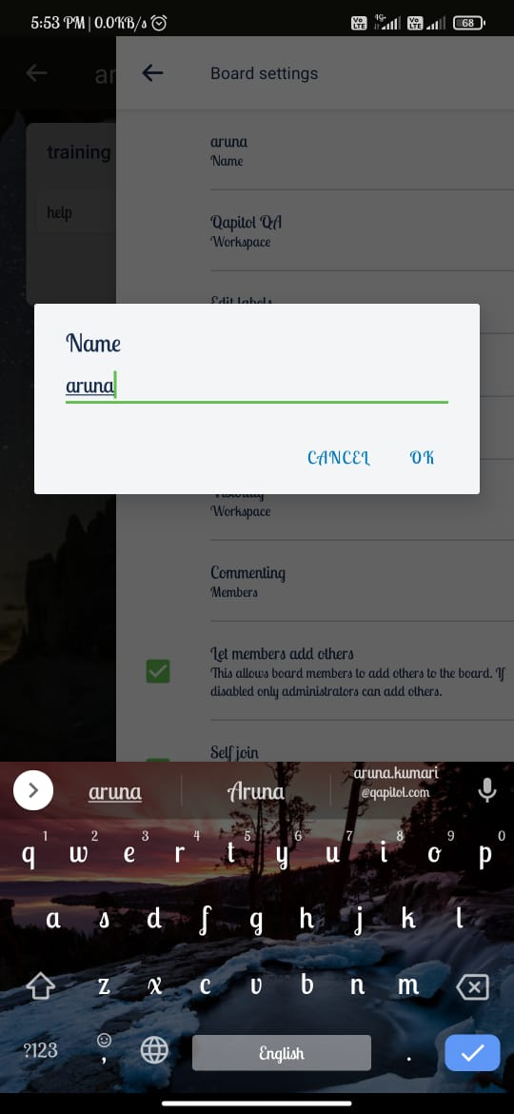

3.After updating board name

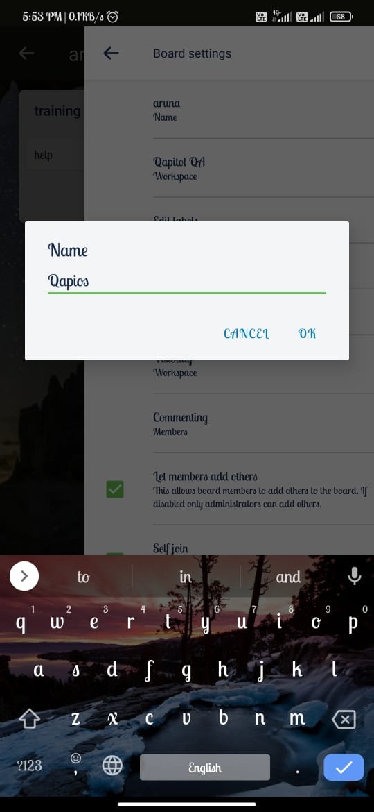

4.Before changing background

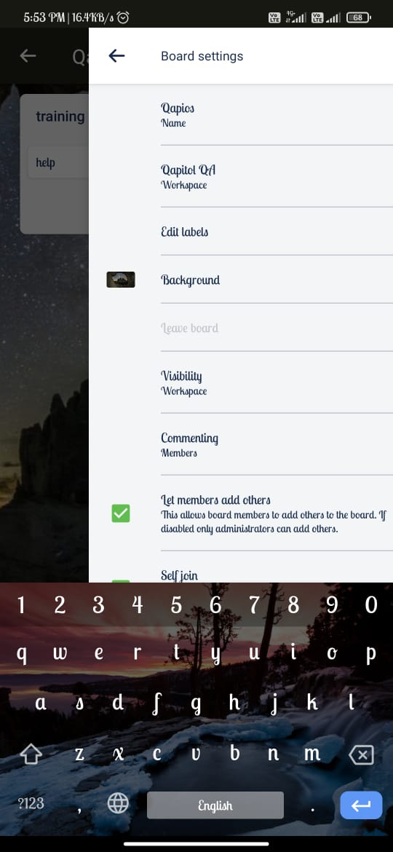

5.After changing background

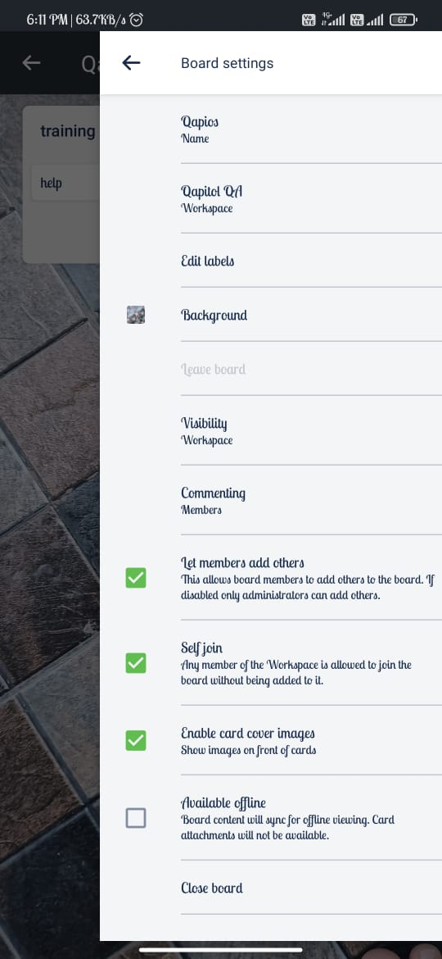

6.After changing visibility from workspace to private

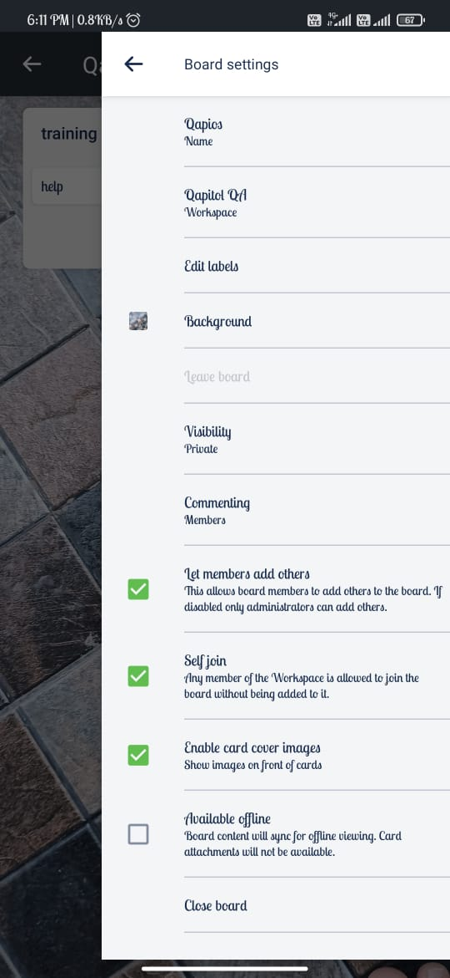

7.After changing commenting from members to disabled

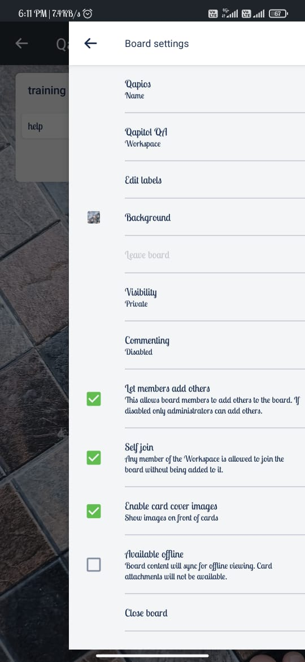

**Members Test case**

1.For adding a member in the Board list

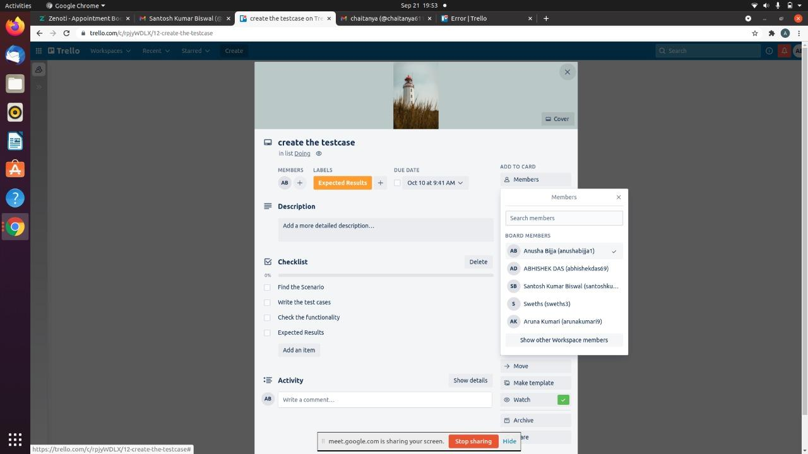

2.Before add a member in the Board list

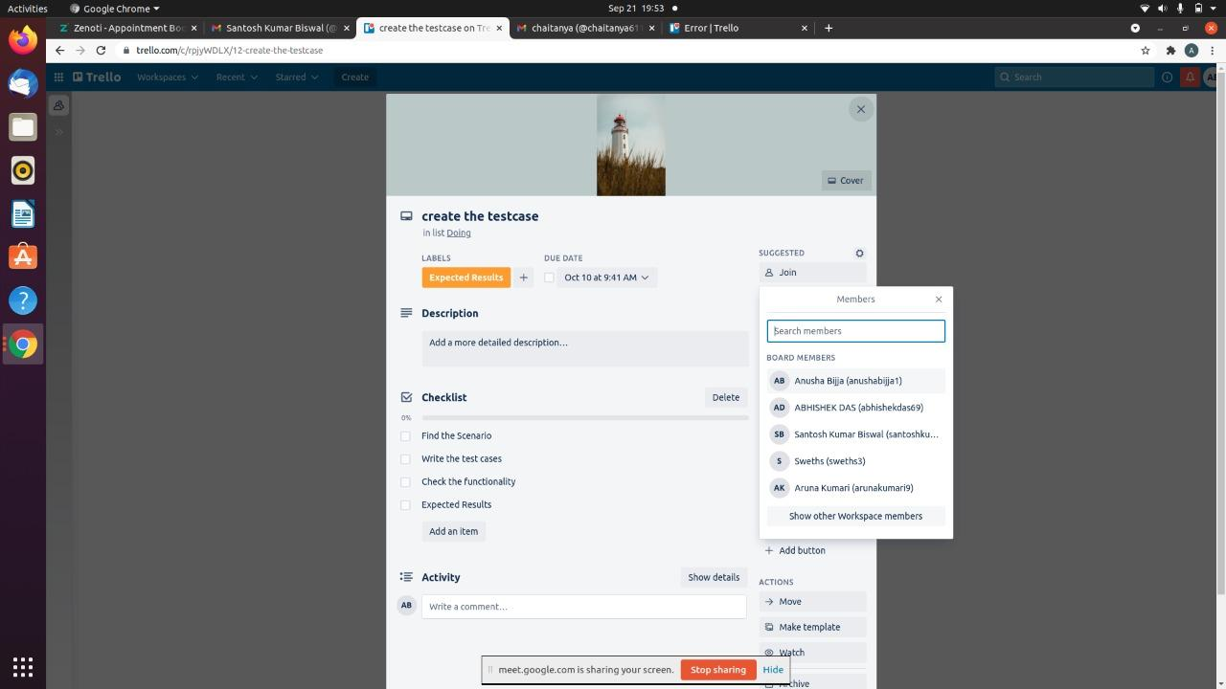

3.After all member added in the Board list

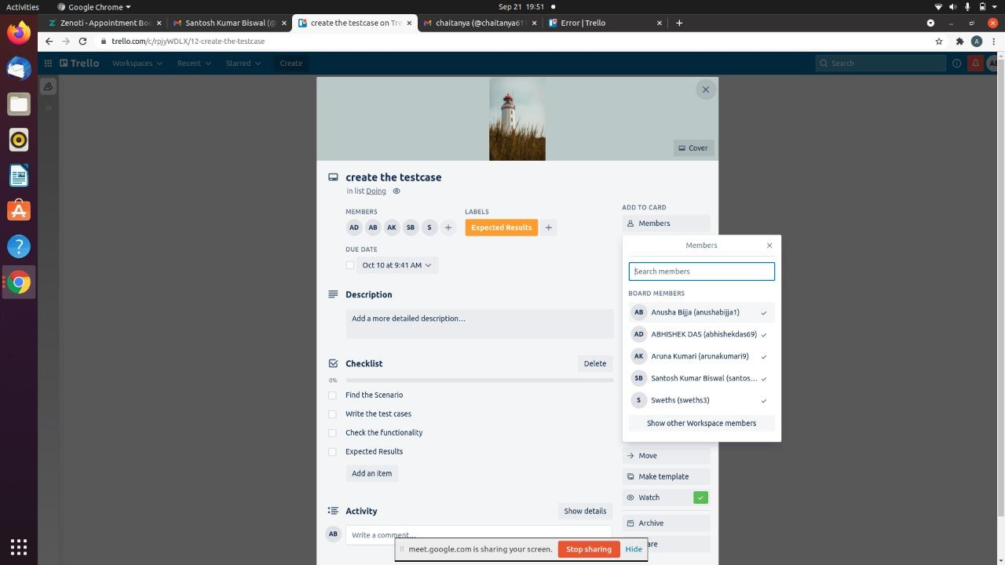

4.Member is not in the Board list

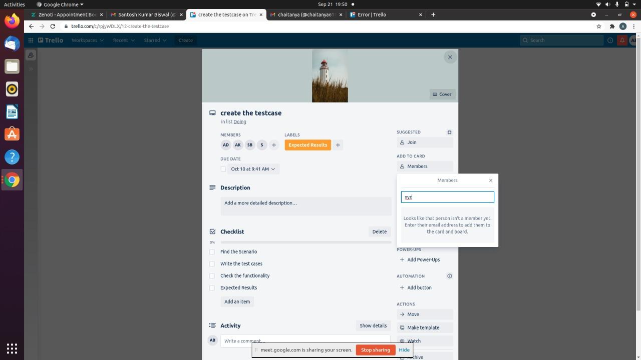

5.Add a member in list

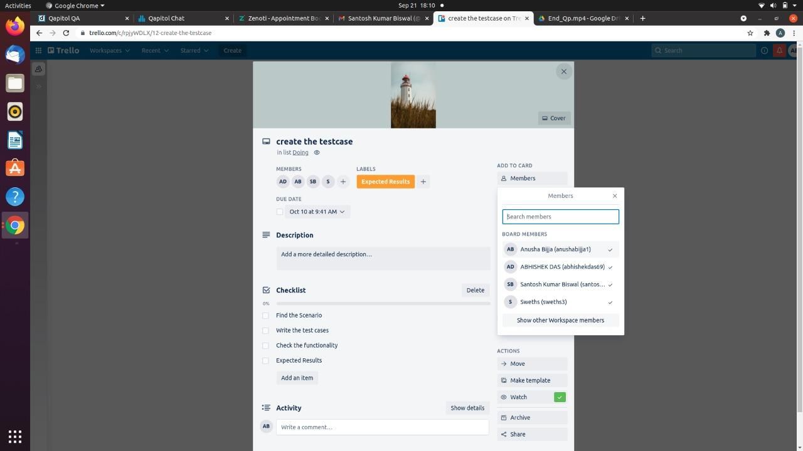

**Labels Test case**

1.Creating new label

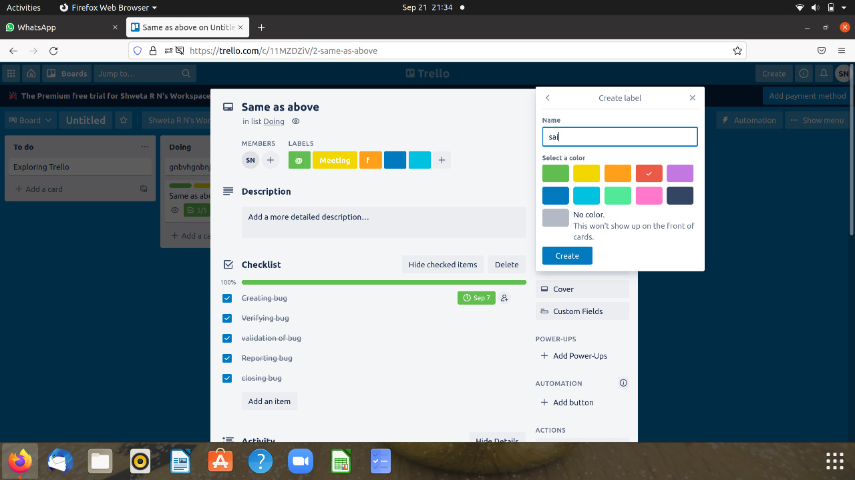

2.Verifying whether its accepting alphabets,numeric,special symbol,space

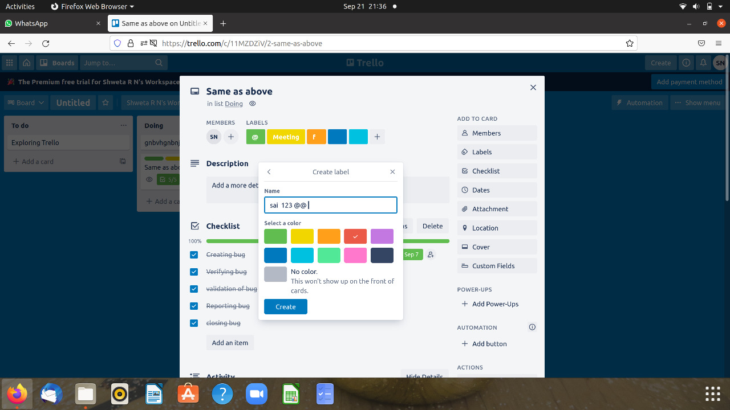

3.Searching existing label and editing label saving label

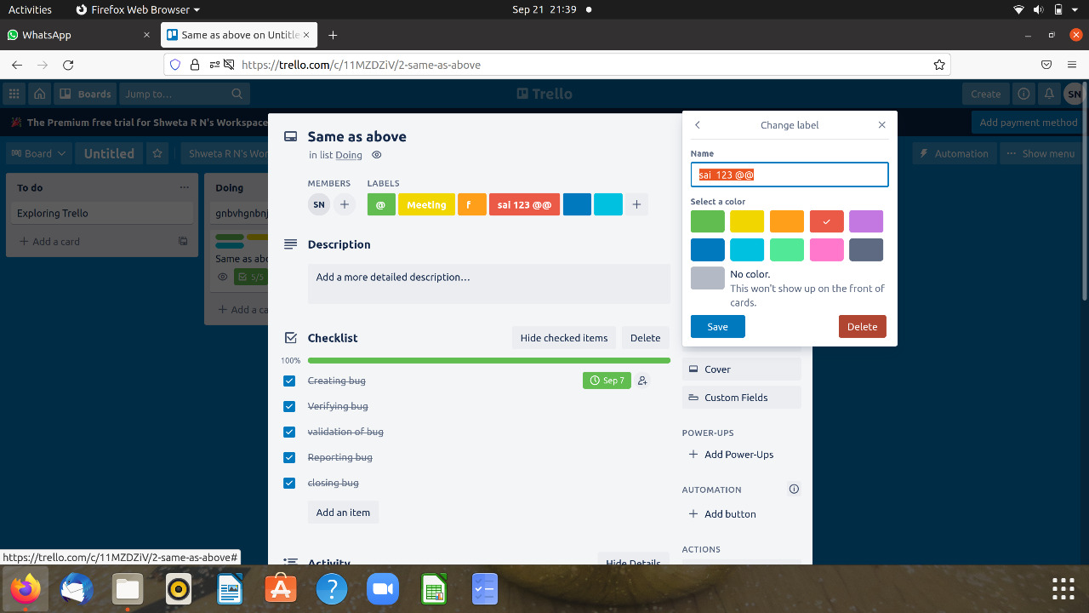

4.Selecting color of label

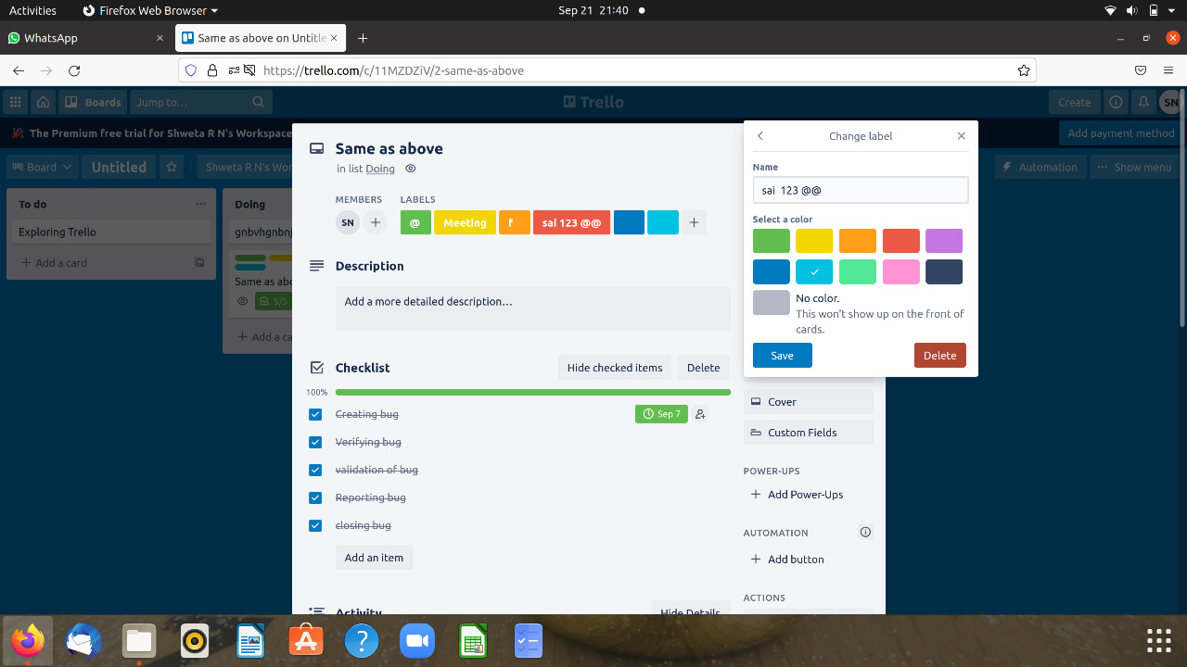

5.After clicking delete button confirmation window should come

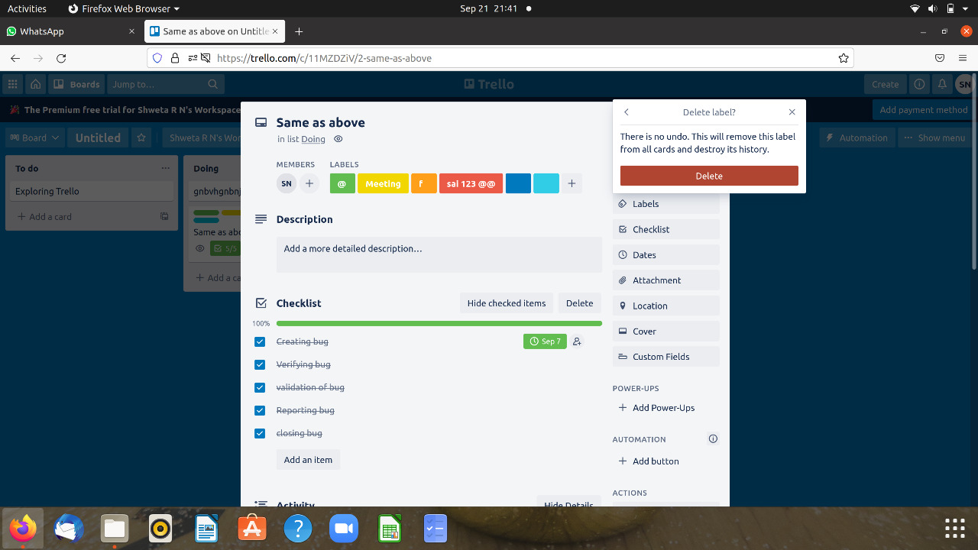

6.Enabling color blind friendly mode

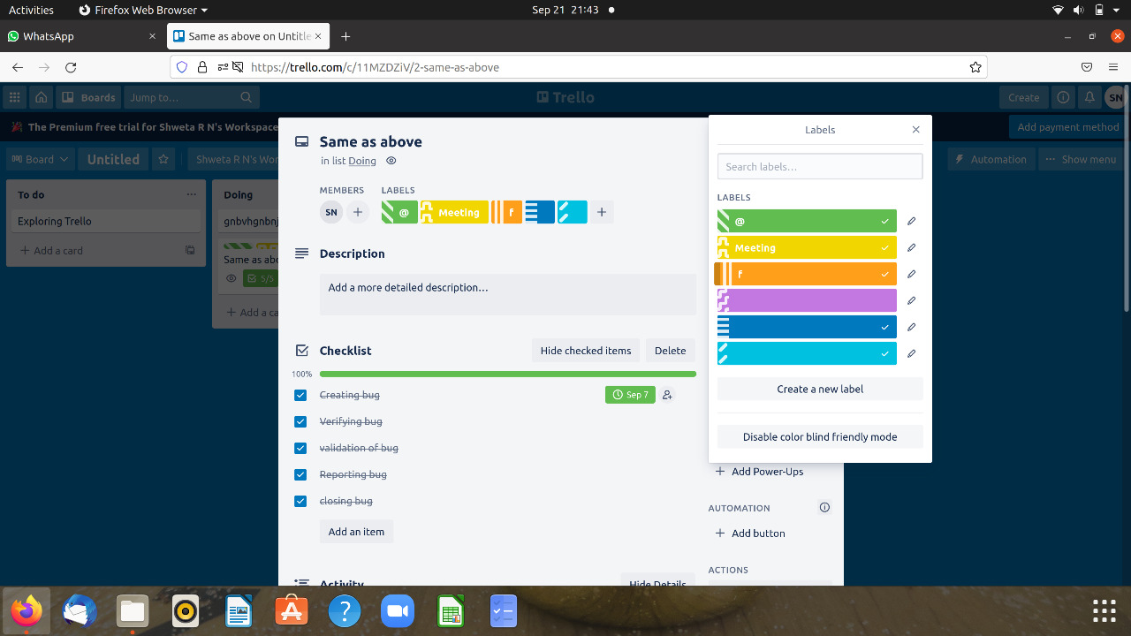

7.Disabling color blind friendly mode

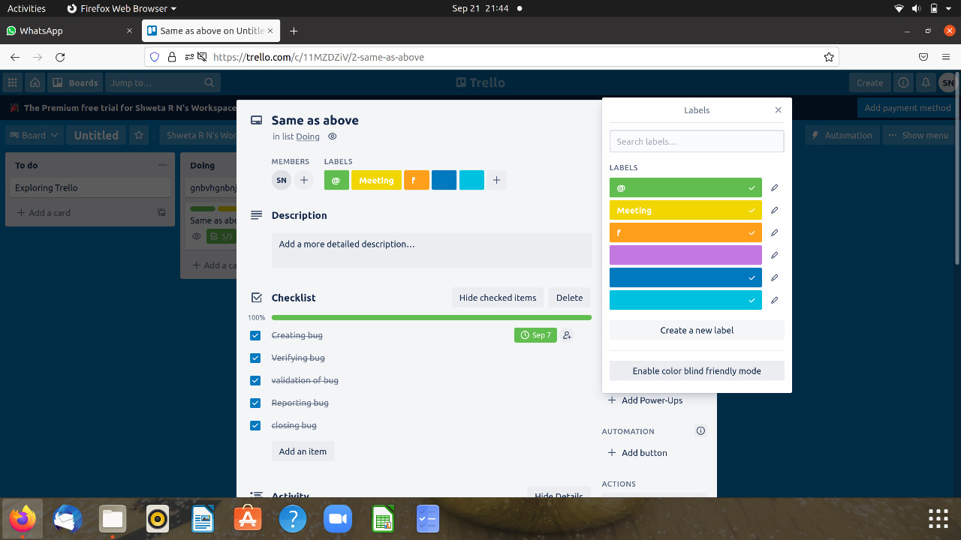

7.Created label should display in label list

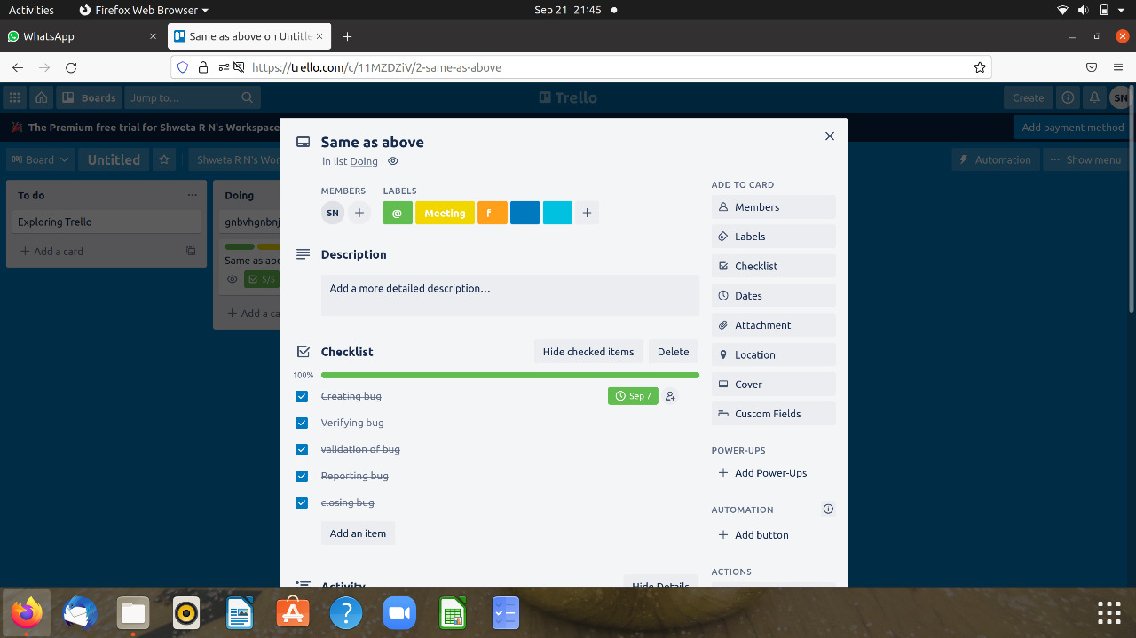

8.Verifying whether text is accepting all letters,number, special symbole,space

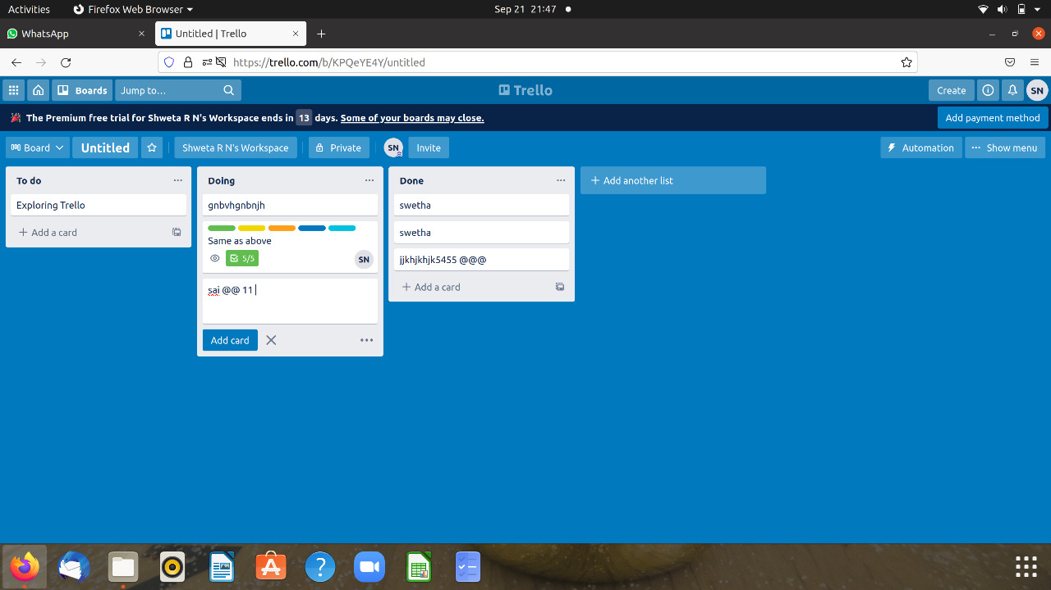

9.Checking card added or not

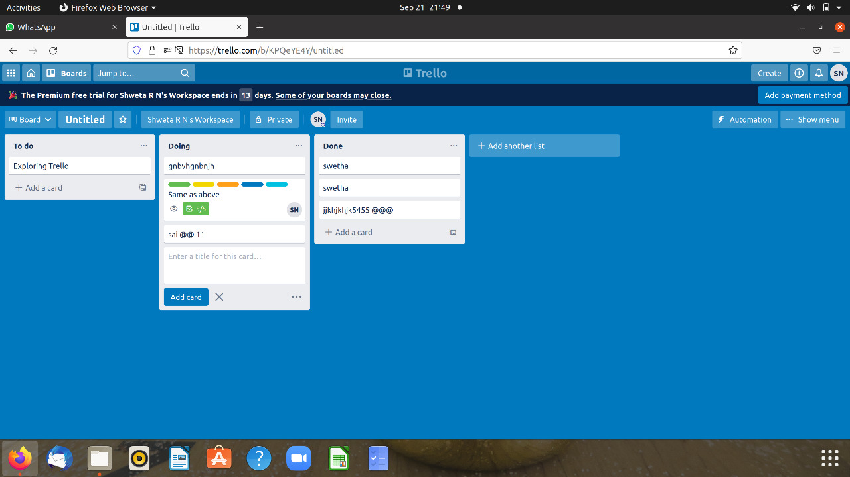

10.Checking delete button and verify whether it deleted or not

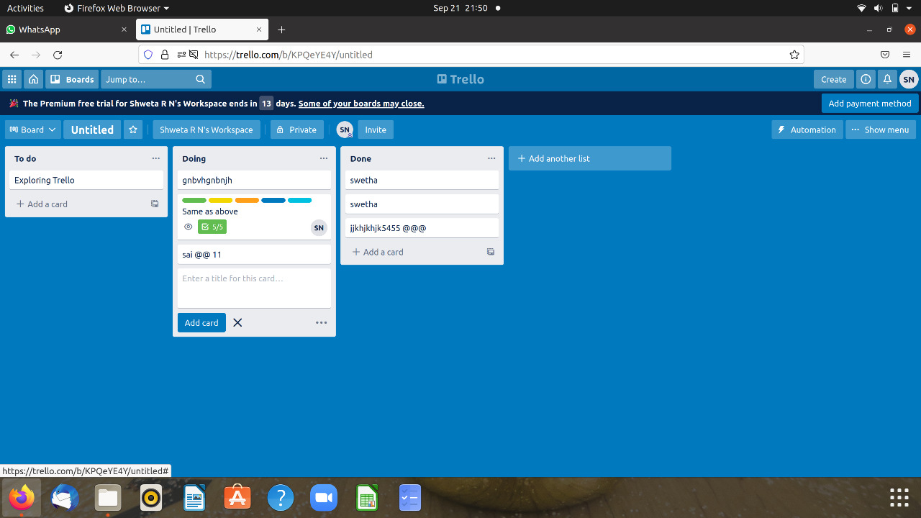

**Tested by:**(Dr.Strange group)

**1.**Santosh kumar biswal

2.Abhishek Das

3.Anusha Bijja

4.Swetha

5.Aruna Kumari